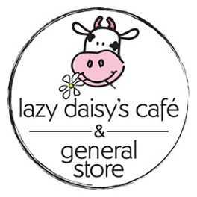
Lazy Daisy’s Café
Buttermilk Pancakes
Serves 3-4
Makes 16 Pancakes
Double the recipe if you have big eaters or want to freeze them. You can always pop them in your toaster for a quick snack!
Materials Needed
1 large non-stick frying pan
non-stick spray
1 spatula
1 whisk
Measuring spoons
1 cup measure
¼ cup measure
2 large mixing bowls

Extras

Have to hand your favourite pancake toppings. A few of our family faves are:
Blueberries / Banana & Chocolate Chips / Strawberries / Whipped Cream

Make your pancakes into a full meal deal by adding breakfast sausages or smoked bacon on the side. I’ll be cooking up my fave breakfast sausages from Fresh From the Farm located on Donlands.

Ingredients
Dry
2 cups all-purpose flour
1/4 cup white sugar
1 tbsp baking powder
1.25 tsp table salt
Wet
2 eggs, beaten
2 cups buttermilk
1 tsp vanilla
1/4 cup vegetable oil
Directions
- Mix together all dry ingredients in one bowl
- Whisk together all wet ingredients in a separate bowl
- Add the wet mix to the dry mix then be sure to whisk out all dem lumps!.
- Let batter sit at least 5 - 10 minutes before cooking
- Warm your pan over medium low heat. Spray with cooking oil (butter tends to overbrown the edges). Using the ¼ cup measure, scoop batter and place in frying pan so they form medium size circles
- Let cook until batter begins to bubble then flip
- If you are adding toppings now is the time to add them!
- Continue cooking for another minute or so until second side is lightly and perfectly browned and batter is cooked all through the center. (careful – your pan might get hotter over time so cooking time will decrease)
- Plate, serve and enjoy!

